Test_2(7th march)

Q1

//Q1

#include<stdio.h>

void main(){

int num1,num2,num3;

printf("Enter num1:");

scanf("%d",&num1);

printf("Enter num1:");

scanf("%d",&num2);

printf("Enter num1:");

scanf("%d",&num3);

if(num1>num2){

if(num1>num3){

printf("%d is greater",num1);

}

else{

printf("%d is greater",num2);

}

}

else{

if(num2>num3){

printf("%d is greater",num2);

}

else{

printf("%d is greater",num3);

}

}

}

o/p

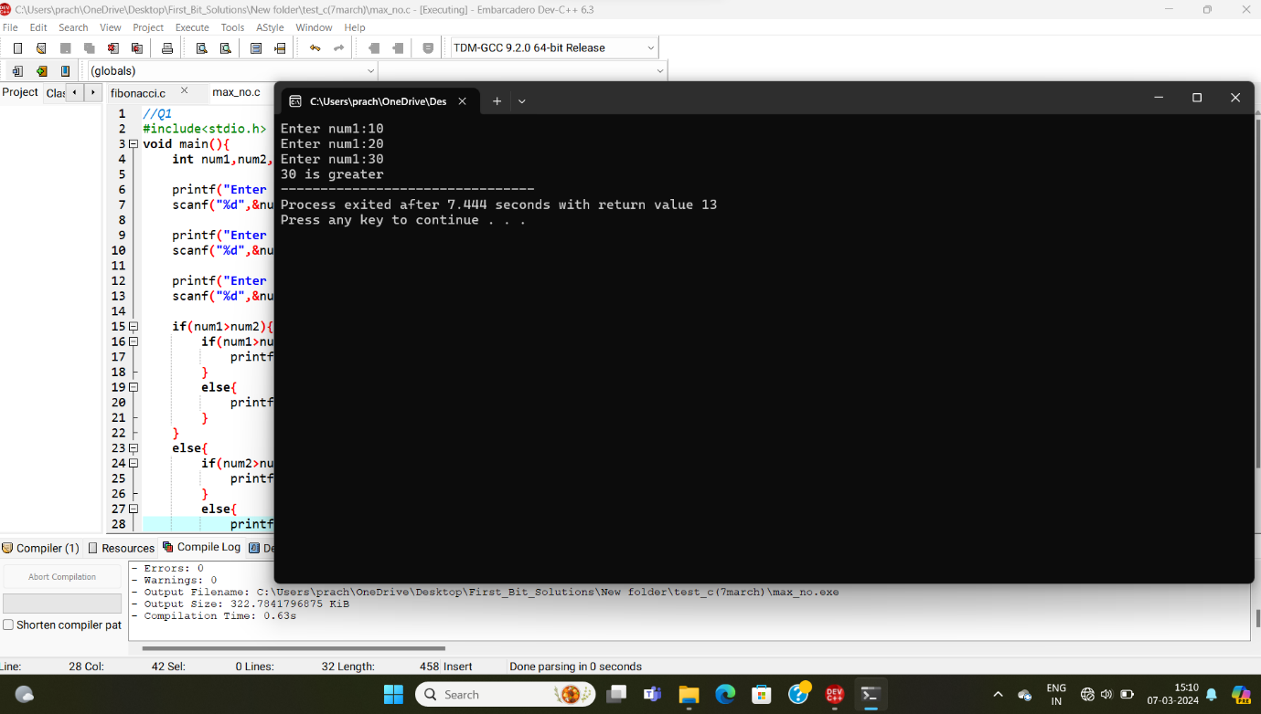

**********************************************************************************

Q2

//grades

#include<stdio.h>

void main(){

int total_marks;

printf("Enter Your Total_marks:");

scanf("%d",&total_marks);

if(total_marks>75){

printf(" Grade is :A+");

}

else{

if(total_marks>60){

printf("Grade is :A");

}

else{

if(total_marks>50){

printf("Grade is :B");

}

else{

if(total_marks>35)

printf("Pass");

else

printf("fail");

}

}

}

}

o/p

